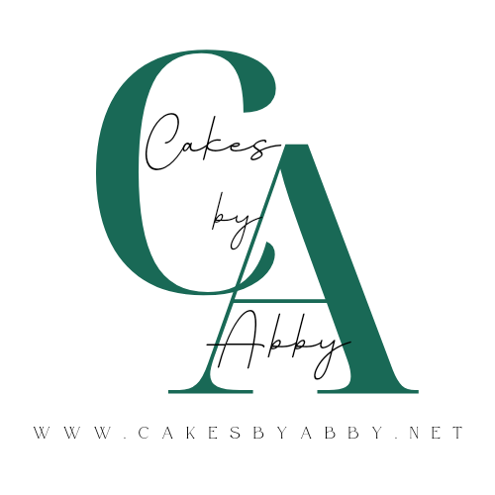
Wedding Cakes
Menu
Cake Flavors:
Vanilla, chocolate, lavender, spice, almond, lemon, orange, red velvet, funfetti
Fillings:
Caramel, chocolate-hazelnut spread, jams (raspberry, strawberry, sour cherry, blueberry, blackberry, apricot, peach), chocolate ganache, crunchy cookie butter, any buttercream
Frosting:
Meringue-based Buttercream: vanilla, chocolate, espresso, salted caramel, chocolate-hazelnut, hazelnut, almond, raspberry, strawberry, lemon, orange, maple, peanut butter, peppermint, cookie butter, toasted coconut

Pricing:
Your wedding cake is a once in-a-lifetime centerpiece dessert! These delicious artistic creations require time, effort, and skill: the time to plan, design, and execute is considerable. The ingredients used are of high quality, including Tcho chocolate and cocoa powder, Slofoodgroup pure vanilla extract and paste, and Valrhona Inspiration fruit couverture. The planning of the booking is no small time commitment: from ensuring you get what you want in the perfect design, to legal matters, the effort to ensuring all details have been considered is great. This is reflected in the pricing structure.
Base price $8.50 per serving; includes any cake flavor, filling and buttercream covering, with minimal decoration (texturing and/or base coloring of buttercream). Additional costs for different decoration elements:
Fresh/silk/dried flowers: Floral arrangement prices are design based: a modest arrangement on a small 2-tier cake will generally start at $50.
Gold or Silver leaf: starts at $1 per serving
Painted/piped Buttercream floral design: starting costs as per florals above, with a starting price of about $35
Wafer paper scultpure: starts at $50
Sheet cakes are $4 per serving and are undecorated.
Cupcakes: start at $48 per dozen for standard-sized unfilled (additional fees dependent on decoration, fillings, and size). Filled cupcakes start at $53 per dozen. Cupcakes at base pricing are modestly decorated with varying piped buttercream textures and edible pearls/sprinkles.
Mini cupcakes are by the 2 dozen ($47 per 2 dozen) and are minimally decorated.
Limit of 12 dozen cupcakes or 12 sets of 2 dozen mini cupcakes per booking.
Delivery fee: #hrs drive x $100
I am based in Chestertown, so pricing is drive time from there. If the drive time is 30min, the delivery fee is $50. This will adjust per location and time of year: if beach and/or bridge traffic is likely, the delivery price will reflect that. Gas prices have affected delivery quotes, as well, and estimates will vary based on current factors.
Tastings:
Cake tastings start at $42 ($45 for Gluten Free) for 3 flavors. Each flavor combo is a 4 inch mini cake, with 4 generous servings per mini cake. Additional mini cakes are $14 each ($15 GF). 6 flavor combos is a double box for $84 ($90 for GF). Tasting boxes are custom: you choose 3, 4, 5, or 6 mini cakes, and the cake flavor, filling (if desired), and buttercream flavor of each mini cake in your box. Dairy free is similarly priced to Gluten Free, and may be an extra cost dependent on the specifics of your order
The tasting box is a lot of cake! With each mini cake of 4 generous servings, even the 3 combo box is about 12 dessert portions. It is recommended to plan a gathering to help you eat your cake tasting… adding champagne is a lovely party idea.
Tastings are by pickup only, by appointment, from me in Chestertown, MD.

Estimates, Booking Process, and Payment:
An estimate (or several estimate options) can be given with minimal information (number of servings or cake size desired, any other serving information for other desserts, basic venue/delivery information). Cake inspiration photos, especially references to my work, are very helpful in the estimate process. I will be clear that this is an estimate and a final quote can only be given when all design and delivery details are determined. These basic estimates are for general information-gathering in your search for the right fit with a cake artist.
Once you determine that I am the right cake artist for your wedding, a $200 non-refundable booking fee is required to secure your date and further the design process. This booking fee is applied to your total booking price.
After gathering more information, I will give an estimate with pricing/combination options. Please have your wedding colors, flowers, and aesthetic available before I can determine these estimates. A mood board is wonderful! Cake inspiration pictures and/or references to my work are helpful, and may be requested based on your design brief. I am happy to provide estimates throughout the design process in order help to meet your budget.
Final quotes will be given only after all details are confirmed, and the design sketch is approved. Once a final quote is given, a 50% deposit (less any prior booking fees) is required to secure your cake. Payment balance will be due 30 days prior to delivery of your wedding cake.
Payment options currently available are check, zelle, credit card (subject to 3.5% service fee), and venmo.
Booking Process:
1. Estimate given from basic wedding information
2. Tasting box purchased (optional)
3. First deposit ($200) made to further design process, sign contract
4. Design confirmed, 50% deposit paid
5. Final balance paid and all details confirmed 30 days prior to wedding

Consultation:
If you desire a consultation/meeting to discuss details of your wedding cake further than email correspondence, I require a non-refundable deposit of $50 unless you are already booked in with your booking fee. Please have as many details of your wedding available prior to our meeting. Colors, wedding theme/aesthetic, budget, venue details, day-of timing, flower details (what kinds, which florist you will be using), mood board, and any other details you can provide will be of help to ensure our meeting is productive.
Meetings will be in Chestertown or over video chat. I do not have a dedicated meeting space available, so in-person meeting venues will be determined per local availability. You may coordinate a tasting box pickup with an in-person consultation, however it may not be possible to have your tasting occur while we meet due to public meeting space restrictions.

Contact:
Abigail Robson
Instagram: @cakesbyabbyrobson
Facebook: Cakes by Abby
410-708-4759
abigail@cakesbyabby.net
www.cakesbyabby.net

